Design Patterns
- Singleton Design pattern

Singleton ensures a single instance with controlled global access, but must be implemented carefully to handle threading and edge cases.
A singleton design pattern ensures that a class has only one instance. It provides a global point of access to it.

We use Singleton pattern when we need a single shared resource and we want to control access to that instance.

Some common examples of instances which are singleton are –
- Configuration Manager
- Logger
- Database Connection Pool
- Cache Manager

The key characteristics of a Singleton Design Pattern are –
- It has a private constructor – This prevents object creation from outside.
- The shared instance is static
- There is a public method to access the instance.

Basic Implementation (Lazy Initialization) – Not thread safe

public class Singleton {
private static Singleton instance ; // This is the Singleton instance that would be shared across all.

private Singleton() {} // A private constructor so that no one else can make an object of this Singleton.

public static Singleton getInstance() { // A public method to get the private Singleton instance

if (instance == null)
{
instance = new Singleton(); // As this method is in the same class, the same class can access private members and methods
}

return instance;

}
}

This is not thread safe, because one thread can read the line if(instance == null) and then context-switch. Then another thread can read the same line and get inside the loop. The second thread creates the instance. Now the original threads comes back and creates the object again. Now we have two threads creating the object of the singleton class, which is not what we want.

Thread-Safe Singleton (Synchronized Method)
class Singleton {
private static Singleton instance;

private Singleton() {}

public static synchronized Singleton getInstance() { // By using synchronized we are locking this entire method to be used only by one thread at a time
if (instance == null)
{
instance = new Singleton();
}
return instance;
}
}

The problem with this is, multiple threads will come, and each of them would wait outside the method even if the instance is already created by a thread. This causes performance issues as this is very slow due to synchronization overhead.

The Best way – Double-Checked Locking
class Singleton {
private static volatile Singleton instance;

private Singleton() {}

public static Singleton getInstance() {
if( instance == null)
{
synchronized (Singleton.class) // Few threads will wait here only for the first time when creating the instance, but once the instance is created, they will go back from the outer loop itself.
{
if(instance == null)
{
instance = new Singleton();
}
}
}
return instance;
}
}

Volatile prevents instruction reordering, and ensures visibility across threads.

The real usage of Singleton is in Spring. Spring Beans are Singleton by default. But there is a small distinction –
- The spring Singleton is one instance per container, not strictly global like classic Singleton.

We should not use Singleton when ->
- We need multiple instances later
- When it creates hidden dependencies
- Makes testing difficult (tight coupling)

- Builder
The Builder pattern is used to construct complex objects step by step, allowing us to create different representations of the same object. It separates object construction from its representation.
Builder is used to construct complex objects step-by-step, especially when there are many optional parameters and a need for clean, readable, and immutable design.
Use Builder when –
- A class has too many parameters (especially optional ones)
- We want to avoid telescoping of constructors
- We need immutable objects
- Object creation involves multiple steps.

Without Builder Design Pattern our code would look something like this (Telescoping Constructor Problem) –

class User
{
String name;
int age;
String email;
String phone;

public User(String name) {/*... */}
public User(String name, int age) {/*... */}
public User(String name, int age, String email) {/*... */}

}

The problems with this type of code is, it is Hard to Read, it is error-prone and not at all scalable.

Now, the core idea of Builder Design Pattern is that instead of passing everything in the constructor ->
- Use a builder object
- Set fields step by step
- Then finally call the build() method
The code structure will have ->
- Product (the object being built)
- Builder – An inner static class that builds the object

class User
{
private final String name;
private final int age;
private final String email;
private final String phone;

private User(Builder builder) { // This private Constructor takes a builder object as a parameter
this.name = builder.name;
this.age = builder.age;
this.email = builder.email;
this.phone = builder.phone;
}

public static Builder getBuilder() {
return new Builder();
}

// Inner Static Builder class. As this is in the same class as User, this class would be able to call the private constructor of the User class
public static class Builder {
private final String name;
private int age;
private String email;
private String phone;

public Builder setName(String name)
{
this.name = name;
return this;
}

public Builder setAge(int age)
{
this.age = age;
return this;
}

public Builder setEmail(String email)
{
this.email = email;
return this;
}

public Builder setPhone(String phone)
{
this.phone = phone;
return this;
}

public User build()
{
return new User(this);
}

}
}

Usage ->

User user = User.getBuilder()
.setName("Arjun")
.setAge(26)
.setEmail("abc.com")
.setPhone("124")
.build();

If there are some required parameters like name, then we can pass it in the Constructor. In that case our Builder Constructor would look like this ->

public Builder(String name) {
this.name = name;
}

and the usage would look like this ->
User user = new User.Builder("Arjun")
.setAge(25)
.setEmail("arjun@example.com")
.build();

Now the key advantages are ->
- Redability -> We clearly see what is being set.
- Immutability –> Final object can be immutable
- Flexibility -> Optional parameters handled cleanly
- Method Chaining -> Fluent API improves usability.

The real world Usage includes ->
- StringBuilder in Java
- Lombok @Builder
- HTTP request builders
- Complex DTO creation

- Prototype Pattern

The Prototype pattern is used to create new objects by copying an existing object (prototype) instead of creating them from scratch. It is useful when object creation is expensive or complex.

We use Prototype pattern when :
- Object creation is costly (DB calls, heavy computations)
- We need many similar objects
- We want to avoid rebuilding from scratch.
The core idea of Prototype pattern is that, instead of doing ->
User user = new User(…) // Which is an expensive creation

We do ->
User copy = existingUser.clone()

Now there are 2 types of cloning ->
- Shallow Copy – This copies references. This is faster but risky.
- Deep Copy- This copies the actual objects. This is safer but more expensive.

So what we do is that, for all non-primitive attributes like arrays, Objects, etc – instead of copying their references we copy their value. Now for this we call their clone method. For this, we need to ensure that all the classes which want to do Deep copying have a clone() method. We can use interfaces to put this mandate.

So first we create a Prototype interface with a clone() method in it. Since we don’t know that which class will be calling it and hence which class’ clone’s object we have to return so we will use generics to define that.

interface Prototype<T>
{
T clone();
}

Now our class which wants to tell the world that we can clone it’s objects will implement this interface.

public class Address
{
private String city;

public Address(String city)
{
this.city = city;
}

public String getCity()
{
return city;
}
}

class User implements Prototype<User>
{
private String name;
private Address address; // Address is another class

public User(String name, Address address)
{
this.name = name;
this.address = address;
}

@Override
public User clone() // Here we are overriding the interface's clone() method
{
return new User(this.name, new Address(this.address.getCity()));
}
}

Usage ->

User u1 = new User("Arjun", new Address("Bangalore"));
User u2 = u1.clone();

The advantages of cloning via clone method (Prototype pattern) are ->
- Avoids expensive object creation
- Faster than building from scratch
- Cleaner when object setup is complex

The problems with Prototype pattern are ->
- The deep copy can be tricky.
- Circular reference become complex.

The Prototype Design pattern is used in Object templates, Game development(Character cloning) and Caching pre-built objects.

- Registry Pattern (Prototype Registry)

Registry just means that storing data or objects somewhere and getting a copy of them whenever we need it.

Here we will understand it with the help of Prototype.

A Registry stores pre-created prototype objects and allows us to ->
- Fetch them
- Clone them
Think of it as a central storage of prototypes.

We usually combine Registry with Prototype because instead of creating objects everytime, we store the ready-made prototypes and clone them when needed.

The structure becomes like this ->
- Registry Stores prototypes
- Prototype Supports cloning

class UserRegistry {
private Map<String, User> registry = new HashMap<>();

public void addPrototype(String key, User user)
{
registry.put(key, user);
}

public User getCLone(String key)
{
return registry.get(key).clone();
}
}

Usage ->

UserRegistry registry = new UserRegsitry();

registry.addPrototype("Admin", new User("Admin", new Address("Delhi")));

User clonedUser = registry.getClone("admin");

In real world it is used for Resume templates, Pre-configured system users and Default Configurations.

The Advantages of using Registry with Prototype is ->
- Reduces object creation cost
- Centralized object management
- Easy to extend

So Prototype creates objects by cloning existing ones, and Registry stores and manages these prototypes for reuse.

Question – When will you use Prototype over Factory ?
Answer – We use Prototype over Factory when object creation is expensive, when many similar objects are needed and when copying is cheaper than building.

- Factory Design Pattern
Based on the type of object (interface/abstract class being implemented/extended by multiple classes) we are creating another type of object (interface/abstract class being implemented/extended by multiple classes)

Whenever we have an object or an input parameter and based on that we decided which type of object will be created we use Factory Design Pattern.

The design where we separate out the decision making to a separate class and based on the input parameter we are taking the decision that which object to be created, this is called Practical Factory or Simple Factory. (This is usually an if-else for decision making in the type of object to be created).

The problems without factory are ->
Payment payment = new CreditCardPayment();

Now the issues with this are that there is Tight Coupling, it is hard to change the implementation and it violates the Open/Closed Principle.

We have the following types of Factory Patterns ->
- Simple Factory
- Factory Method
- Abstract Factory

- Simple Factory -> In Simple Factory, we see that the decision of the object to be made is based on an input parameter which is usually a String. So what we do is instead of writing many if-else everywhere for creating an object, we put the if-else decision making in another Factory class.

interface Payment
{
void pay();
}

class CreditCardPayment implements Payment {
public void pay() {
System.out.println("Credit Card Payment");
}
}

class UPIPayment implements Payment {
public void pay()
{
System.out.println("UPI Payment");
}
}

Now we create a Payment Factory class which will decide which class’ object to create.

class PaymentFactory
{
public static Payment getPayment(String type)
{
if(type.equals("CARD"))
{
return new CreditCardPayment();
}
else if(type.equals("UPI"))
{
return new UPIPayment();
}
throw new IllegalArgumentException("Invalid type");

}
}

And this is how we will use it ->
Payment payment = PaymentFactory.getPayment("UPI");
payment.pay();

Now the problem with this is that this also breaks Open/Closed Principle. To add a new type we would have to modify the factory class.

- Factory Method -> In the Factory Method Pattern we let the subclasses decide which object to create. That means, we move the object creation to child classes.

The structure looks like this->

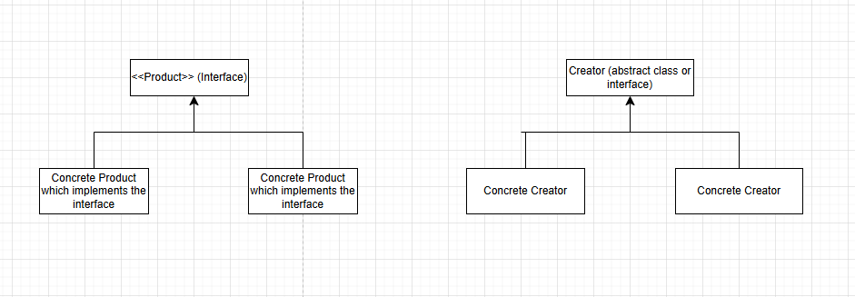

Let’s say that we have a Database Interface which will be implemented by various Databases like MySQL, MongoDB, Postgres, etc. On the other side we have a Query Interface which will be implemented by MySQL Query, MongoDB Query, etc. No we ask the Database interface to please have a createQuery() method which all of its implementing classes will have to implement and it will return a Query object, which would help us to further call the Query methods implemented by classes which have implemented Query interface.

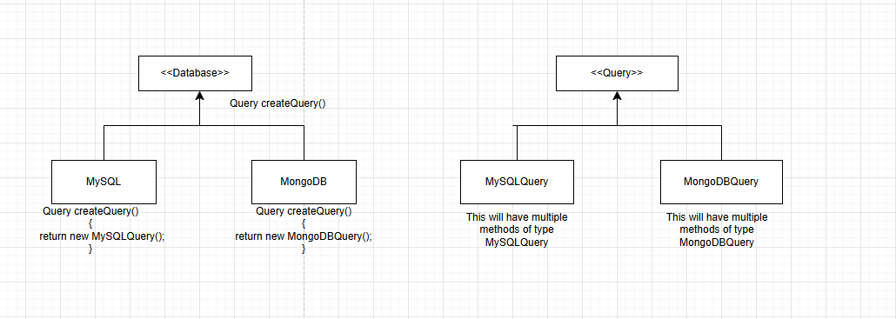

public interface Database {
public Query createQuery();
}

public class MySQL implements Database{
@Override
public Query createQuery() {
return new MySQLQuery();
}
}

public class MongoDB implements Database {
@Override
public Query createQuery() {
return new MongoDBQuery();
}
}

public interface Query {
public void execute();
}

public class MySQLQuery implements Query{
@Override
public void execute() {
System.out.println("Executing MySQL query...");
}
}

public class MongoDBQuery implements Query {
@Override
public void execute() {
System.out.println("Executing MongoDB query...");
}
}

Usage
public class Main
{
public static void main(String[] args)
{
Database db = new MySQL();
Query q = db.createQuery();
q.execute();
db = new MongoDB();
q = db.createQuery();
q.execute();
}
}

Output

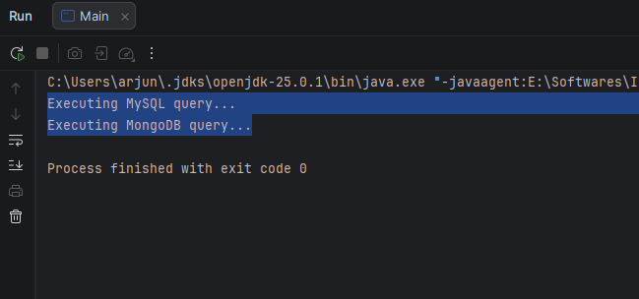

- Abstract Factory -> Now as this worked, we now have more things for example we have a Transaction interface with Transaction methods which will be implemented by classes implementing the Transaction interface. So we go back and ask the Database interface to include another factory method ‘createTransaction()’ which will return the object of Transaction Interface.

At this point the Database stops us and says that – “Hey, I was fine with helping you with one factory method, but now you are taking advantage of me by giving me more and more factory methods. I am not a Factory”.

So, Instead of asking database to create multiple Factory methods, we just ask Database to have one Factory method called createDBFactory which will return us an object of DatabaseFactory. DatabaseFactory is an interface which has factory methods for createQuery(), createTransaction() etc. This will be implemented by Factory classes of each DB – MySQL, MongoDB, etc.

So the structure for abstract factory will look like this ->

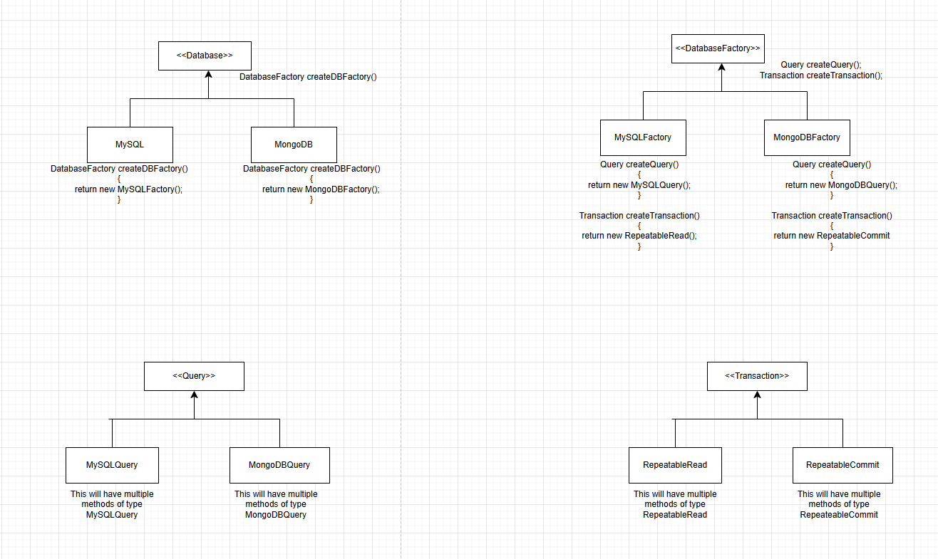

public interface Database {
public DatabaseFactory createDBFactory();
}

public class MySQL implements Database{
@Override
public DatabaseFactory createDBFactory() {
return new MySQLFactory();
}
}

public class MongoDB implements Database {
@Override
public DatabaseFactory createDBFactory() {
return new MongoDBFactory();
}
}

public interface DatabaseFactory
{
Query createQuery();
Transaction createTransaction();
}

public class MySQLFactory implements DatabaseFactory {
@Override
public Query createQuery() {
return new MySQLQuery();
}
@Override
public Transaction createTransaction() {
return new RepeatableRead();
}
}

public class MongoDBFactory implements DatabaseFactory {
@Override
public Query createQuery() {
return new MongoDBQuery();
}
@Override
public Transaction createTransaction() {
return new RepeatableCommit();
}
}

public interface Query {
public void execute();
}

public class MySQLQuery implements Query{
@Override
public void execute() {
System.out.println("Executing MySQL query...");
}
}

public class MongoDBQuery implements Query {
@Override
public void execute() {
System.out.println("Executing MongoDB query...");
}
}

public interface Transaction {
public void read();
}
public class RepeatableCommit implements Transaction{
@Override
public void read() {
System.out.println("Reading data with Repeatable Commit isolation level...");
}
}

public class RepeatableRead implements Transaction {
@Override
public void read() {
System.out.println("Reading data with Repeatable Read isolation level...");
}
}

Usage
public class Main
{
public static void main(String[] args)
{
Database db = new MySQL();
DatabaseFactory dbf = db.createDBFactory();
Query q = dbf.createQuery();
Transaction t = dbf.createTransaction();
q.execute();
t.read();
db = new MongoDB();
dbf = db.createDBFactory();
q = dbf.createQuery();
t = dbf.createTransaction();
q.execute();
t.read();
}
}

Output
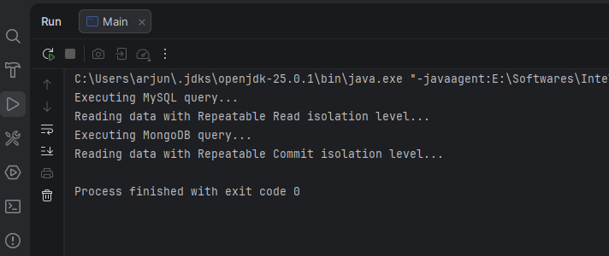

- Adapter Pattern
The Adapter pattern allows two incompatible interfaces to work together. It acts as a ridge between a client and a class with a different interface.

We use Adapter when ->
- We are integrating a third-party or legacy system
- The existing interface does not match with what our system expects
- We cannot modify the existing class.

One Real-World Analogy is Mobile Charge and Plug Adapter. Different countries have different types of Socket. So we take an adapter, from one side it is compatible with our charger and on the other side it is compatible with the country’s socket. So initially, our charger was not able to connect to the socket, but with adapter it was able to connect.

In software terms, this means that no two concrete classes should be dependent on each other. Instead they should be talking to one another via an interface. This way, if we want to change the implementation, we can do it easily by just injecting the object of another class which is implementing the same interface.

In structure, it would look something like this

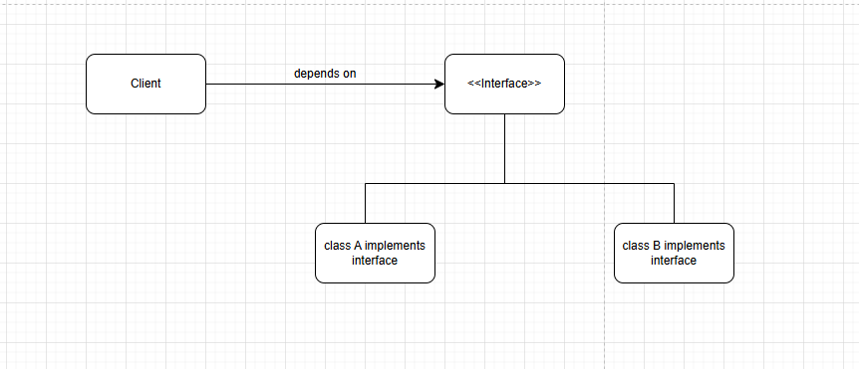

The client depends on Interface and that interface is implemented by 3rd Party APIs. But why would YesBank, ICICI bank implement Interfaces which we ask them to. They can’t implement different interfaces for each customer. So this structure will not work.

This is how the actual correct Structure will look like

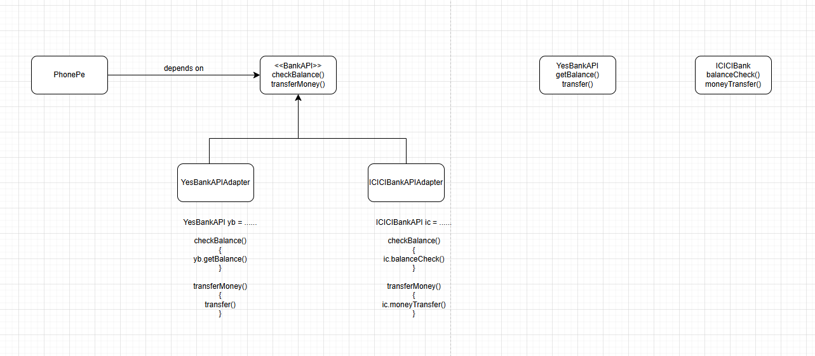

The client(Phonepe) will have to write <<BankAPI>> as well as YesBankAPIAdapter and ICICIBankAPIAdapter.

package DesignPatterns.Adapter;
public interface BankAPI {
public int checkBalance();
public void transferMoney();
}

package DesignPatterns.Adapter.adapters;
import DesignPatterns.Adapter.BankAPI;
import DesignPatterns.Adapter.Banks.ICICIBankAPI;
public class ICICIBankAPIAdapter implements BankAPI {
ICICIBankAPI iciciBankAPI = new ICICIBankAPI();
@Override
public int checkBalance() {
return iciciBankAPI.balanceCheck();
}
@Override
public void transferMoney() {
iciciBankAPI.moneyTransfer();
}
}

package DesignPatterns.Adapter.adapters;
import DesignPatterns.Adapter.BankAPI;
import DesignPatterns.Adapter.Banks.YesBankAPI;
public class YesBankAPIAdapter implements BankAPI {
YesBankAPI yesBankAPI = new YesBankAPI();
@Override
public int checkBalance() {
return yesBankAPI.getBalance();
}
@Override
public void transferMoney() {
yesBankAPI.transfer();
}
}

package DesignPatterns.Adapter.Banks;
public class ICICIBankAPI {
public int balanceCheck()
{
System.out.println("Fetching Balance from ICICIBank");
return 200;
}
public void moneyTransfer()
{
System.out.println("Money transfer from ICICIBank");
}
}

package DesignPatterns.Adapter.Banks;
public class YesBankAPI {
public int getBalance() {
System.out.println("Fetching Balance from YesBank");
return 100;
}
public void transfer()
{
System.out.println("Transferring Money from YesBank");
}
}

Usage
package DesignPatterns.Adapter;
import DesignPatterns.Adapter.adapters.ICICIBankAPIAdapter;
import DesignPatterns.Adapter.adapters.YesBankAPIAdapter;
public class PhonePe {
public static void main(String[] args) {
BankAPI bankAPI = new YesBankAPIAdapter();
bankAPI.checkBalance();
bankAPI.transferMoney();
bankAPI = new ICICIBankAPIAdapter();
bankAPI.checkBalance();
bankAPI.transferMoney();
}
}

Output
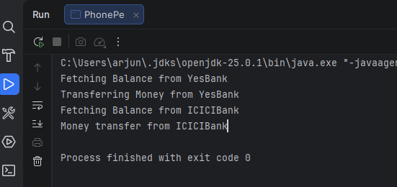

- Facade Design Pattern
Façade means a boundary or outside of a building, or a deceptive appearance.

Façade is just abstraction.
Facade provides a simplified interface to a complex subsystem. It hides complexity and exposes only what is needed.

We use Façade when The system is complex, it has too many dependencies and we want to expose a clean API.
The real world analogy would be
- Remote Control (we don’t interact with internal circuits)
- Customer support desk (handles multiple backend systems)

One example would be that the Home Theater System has –
- Projector
- Sound System
- Lights
But the user just wants “Start Movie”.

So what happens in Façade is that the client is exposed a single method which it calls, and that method internally calls multiple other complex methods. The class that has the single method which is exposed to the client is the Façade.

Façade is just beautification of something very complex.

package DesignPatterns.Facade;
public class Lights {
public void dim()
{
System.out.println("Dimming the lights...");
}
}

package DesignPatterns.Facade;
public class Projector {
public void on()
{
System.out.println("Switching on the projector...");
}
}

package DesignPatterns.Facade;
public class SoundSystem {
public void on()
{
System.out.println("Switching on the Sound System ...");
}
}

package DesignPatterns.Facade;
public class HomeTheaterFacade
{
private Lights lights;
private Projector projector;
private SoundSystem soundSystem;
public HomeTheaterFacade(Lights lights, Projector projector, SoundSystem soundSystem)
{
this.lights = lights;
this.projector = projector;
this.soundSystem = soundSystem;
}
public void watchMovie()
{
System.out.println("Get ready to watch a movie...");
lights.dim();
projector.on();
soundSystem.on();
}
}

package DesignPatterns.Facade;
public class Client {
public static void main(String[] args) {
HomeTheaterFacade homeTheater = new HomeTheaterFacade(new Lights(), new Projector(), new SoundSystem());
homeTheater.watchMovie();
/*
Without the Facade, the client would have to do the following -->
Lights lights = new Lights();
lights.dim();
Projector projector = new Projector();
projector.on();
SoundSystem soundSystem = new SoundSystem();
soundSystem.on();
*/
}
}

The Key advantages of Façade Design Pattern are following
- Simplifies usage
- Reduces coupling
- Improves readability

- Decorator Pattern
The Decorator pattern allows us to add behaviour to an object dynamically without modifying its class. It wraps an object and enhances its functionality.
Decorator wraps an object to dynamically add new behaviour without modifying the original class.

We use Decorator Design Pattern when ->
- We want to add features at runtime
- We want to avoid class explosion due to inheritance (class Explosion means that for every new thing we have to create a class, leading to a lot of classes)
- We want flexible combinations of behaviours.

For example, lets say that we have our coffee shop called “StarBuxx”. It has the following functionalities –
- Build the beverage
- Get cost
- Get description

For the beverage we have different types of Milk(Normal, Soya, Almond), different types of Coffee(DarkRoast, Expresso, etc), and multiple other things. One bad way to implement this is to have classes for all the permultations and combinations. For example
Class MilkDarkRoast
Class SoyDarkRoast
Class MilkMochaExpresso.
Class DoubleMilkDarkRoast

This is the bad way, do not implement it.

We want to add customizations to our beverage at runtime. To add a new class we would have to stop the application. The customer would come and say that, I want Soy Milk, 2 pumps or sugar, Mocha, etc. All this has to be handled at runtime. So we have to add dynamically the customization.

So our structure will look something like this

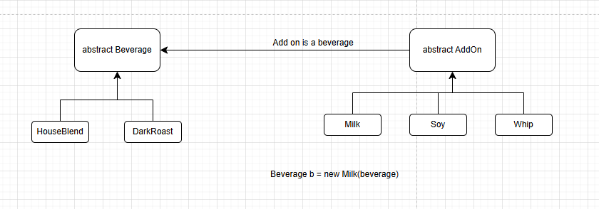

AddOn abstract class depends on Beverage. And hence, Milk, Soy, etc are also Beverages. Here we can say that to create a new Beverage, we need to wrap it on another Beverage. That means, that Milk cannot exist alone, we need to add it on top of a beverage, and even after adding Milk, the Beverage will still remain a beverage.

package DesignPatterns.Decorator;
public abstract class Beverage {
public abstract void getDescription();
public abstract int getCost();
}

package DesignPatterns.Decorator;
public class DarkRoast extends Beverage {
@Override
public void getDescription() {
System.out.println("Dark Roast Coffee");
}
@Override
public int getCost() {
return 30;
}
}

package DesignPatterns.Decorator;
public class HouseBlend extends Beverage {
@Override
public void getDescription() {
System.out.println("House Blend Coffee");
}
@Override
public int getCost() {
return 10;
}
}

package DesignPatterns.Decorator;
public abstract class AddOns extends Beverage {
public Beverage beverage;
public AddOns(Beverage beverage) {
this.beverage = beverage;
}
}

package DesignPatterns.Decorator;
public class ChocoChip extends AddOns{
public ChocoChip(Beverage beverage) {
super(beverage);
}
@Override
public void getDescription() {
beverage.getDescription();
System.out.println("Adding Choco Chip...");
}
@Override
public int getCost() {
return beverage.getCost() + 20;
}
}

package DesignPatterns.Decorator;
public class Milk extends AddOns{
public Milk(Beverage beverage) {
super(beverage);
}
@Override
public void getDescription() {
beverage.getDescription();
System.out.println("Adding milk to the beverage...");
}
@Override
public int getCost() {
return beverage.getCost() + 10;
}
}

package DesignPatterns.Decorator;
public class Soy extends AddOns {
public Soy(Beverage beverage) {
super(beverage);
}
@Override
public void getDescription() {
beverage.getDescription();
System.out.println("Adding Soy");
}
@Override
public int getCost() {
return beverage.getCost() + 20;
}
}

package DesignPatterns.Decorator;
public class Whip extends AddOns{
public Whip(Beverage beverage) {
super(beverage);
}
@Override
public void getDescription() {
beverage.getDescription();
System.out.println("Adding Whip");
}
@Override
public int getCost() {
return beverage.getCost() + 10;
}
}

Usage
package DesignPatterns.Decorator;
public class Client {
public static void main(String[] args) {
// Creating a Beverage with DarkRoast Coffee, 1 Milk, 1 Whip and 2 ChocoChips
Beverage b1 = new ChocoChip(new ChocoChip(new Whip(new Milk(new DarkRoast()))));
b1.getDescription();
System.out.println("Total Cost: " + b1.getCost());
}
}

Output

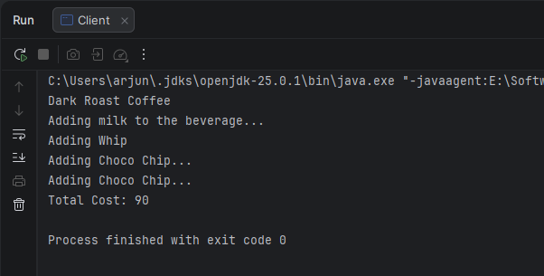

- Flyweight Design Pattern

Flyweight is used to reduce memory usage by sharing common objects. Instead of creating many many objects, reuse existing ones.

Use Flyweight when –
- You have a large number of similar objects
- Objects share common data
- Memory optimization is important

The core idea is to split the object state into two states
- Intrinsic state – shared (stored in flyweight) – remains same across a type
- Extrinsic state – passed outside the class

So let’s say that we have a class with 10 attributes. While creating multiple objects, we noticed that out of these 10 attributes, 6 are always same for many objects. For example, out of 1000 objects, those 4 attributes are varying for all 1000 objects, but the 6 objects are same for 300 objects, then again same for another 300 objects and so on. So we split this one class into two classes – class A and class B.
In class B, we have the 6 attributes which are not changing.
In class A, we have the 4 attributes which are changing, plus a reference to class B.

So now, we create 1000 objects of class A, and 5-8 objects of class B. Class A will also have a reference attribute pointing to that object of class B which has those set set of values of the 6 attributes needed by that variation of class A objects.

- Strategy Design Pattern
The Strategy Design Pattern is a behavioral design pattern that allows us to define a family of algorithms, encapsulate each one into a separate class, and make them interchangeable at runtime. This means an object can change its behavior at runtime by selecting different strategies without modifying the object’s code.

Strategy encapsulates interchangeable behaviors and allows switching them at runtime.

So at runtime, the client can decide to go with Algo 1, or Algo 2 or Algo 3, without changing or modifying the object’s code

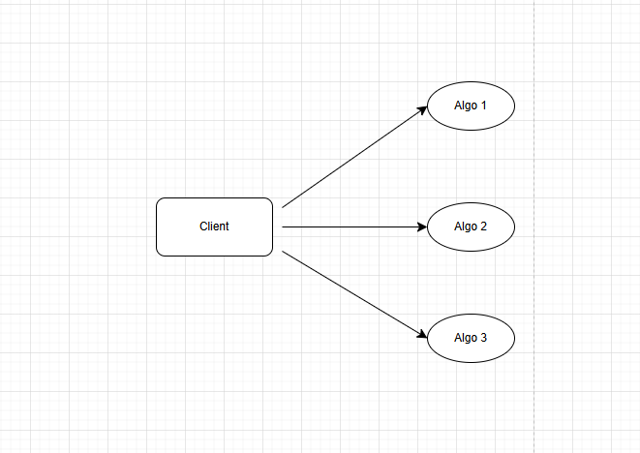

One example is Login. When we go on a Login page, we get multiple options. Login via Email and Password. Login via Google, Login via Facebook, etc.

This is how we implement it
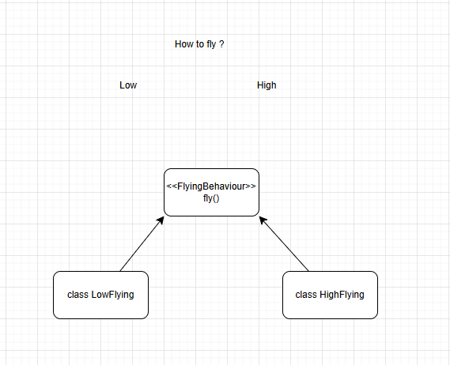

FlyingBehaviour is the Strategy Interface.

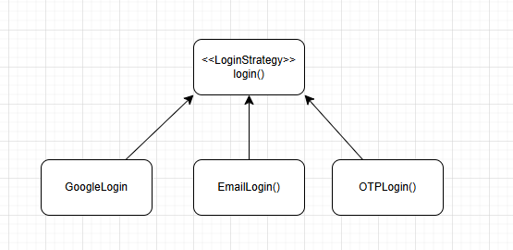

Most of the places where we will be using Strategy, it will be used with Factory.

Strategy tells us to define the different algorithms and encapsulate it in different classes under the same umbrella (interface) so that they can be interchangeable, and factory helps us choose from them.

package DesignPatterns.Strategy;
public interface LoginStrategy {
public void login();
}

package DesignPatterns.Strategy;
public class EmailLogin implements LoginStrategy {
@Override
public void login() {
System.out.println("Logging in with email and password...");
// Implement email login logic here
}
}

package DesignPatterns.Strategy;
public class GoogleLogin implements LoginStrategy{
public void login() {
System.out.println("Google Login");
}
}

package DesignPatterns.Strategy;
public class OTPLogin implements LoginStrategy{
public void login() {
System.out.println("OTP Login");
}
}

package DesignPatterns.Strategy;
public class LoginFactory {
public static LoginStrategy createLoginStrategy(String loginType) {
if(loginType.equals("Google")){
return new GoogleLogin();
}
else if(loginType.equals("Email"))
{
return new EmailLogin();
}
else if(loginType.equals("OTP"))
{
return new OTPLogin();
}
throw new IllegalArgumentException("Invalid Login Type");
}
}

Usage
package DesignPatterns.Strategy;
import java.util.Scanner;
public class Client {
public static void main(String[] args)
{
Scanner sc = new Scanner(System.in);
System.out.println("Please enter how do you want to Login");
String loginType = sc.nextLine();
LoginFactory loginFactory = new LoginFactory();
LoginStrategy loginStrategy = loginFactory.createLoginStrategy(loginType);
loginStrategy.login();
}
}

Output
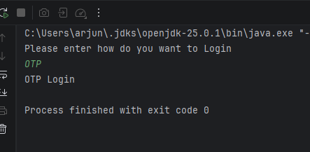

Another good example

Step 1: Strategy Interface
interface PaymentStrategy {
void pay(int amount);
}

Step 2: Concrete Strategies
class CreditCardPayment implements PaymentStrategy {
public void pay(int amount) {
System.out.println("Paid using Credit Card: " + amount);
}
}
class UpiPayment implements PaymentStrategy {
public void pay(int amount) {
System.out.println("Paid using UPI: " + amount);
}
}

Step 3: Context
class PaymentService {
private PaymentStrategy strategy;
public PaymentService(PaymentStrategy strategy) {
this.strategy = strategy;
}
public void processPayment(int amount) {
strategy.pay(amount);
}
}

Step 4: Usage
public class Main {
public static void main(String[] args) {
PaymentStrategy strategy = new UpiPayment();
PaymentService service = new PaymentService(strategy);
service.processPayment(1000);
// Change behavior at runtime
service = new PaymentService(new CreditCardPayment());
service.processPayment(2000);
}
}

- Observer Pattern

Observer defines a one-to-many dependency where when one object (Subject) changes state, all dependent objects (Observers) are notified automatically. It is a Behavioural Design Pattern.

The observer design pattern works on the push method.

The structure will look like this

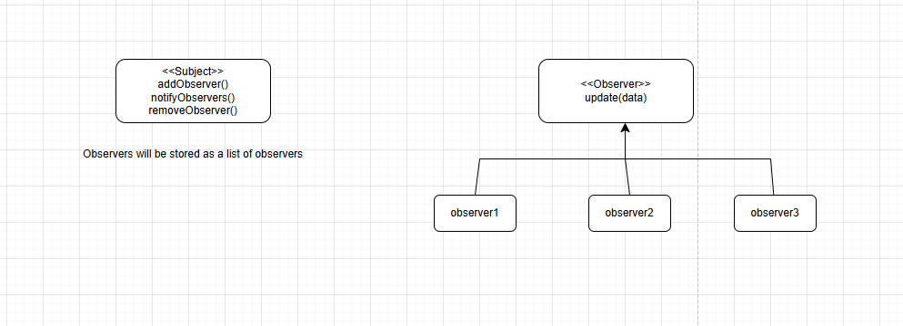

We use Observer Pattern when multiple objects need updates from one source and we want loose coupling between components.

Some real world examples are
- YouTube subscribers
- Stock price updates
- Notification systems

package DesignPatterns.Observer;
public interface Subject {
public void addObserver(Observer o);
public void removeObserver(Observer o);
public void notifyObservers();
}

package DesignPatterns.Observer;
import java.util.ArrayList;
import java.util.List;
public class NotificationService implements Subject{
private List<Observer> observers;
String message;
public NotificationService() {
observers = new ArrayList<Observer>();
}
public void setMessage(String message){
this.message = message;
notifyObservers();
}
@Override
public void addObserver(Observer o) {
observers.add(o);
}
@Override
public void removeObserver(Observer o) {
observers.remove(o);
}
@Override
public void notifyObservers() {
for(Observer o : observers){
o.update(message);
}
}
}

package DesignPatterns.Observer;
public interface Observer {
public void update(String message);
}

package DesignPatterns.Observer;
import java.util.Observable;
public class EmailService implements Observer{
public void update(String message) {
System.out.println("Email Service received message: " + message);
}
}

package DesignPatterns.Observer;
public class SMSService implements Observer{
@Override
public void update(String message) {
System.out.println("SMS Service received message: " + message);
}
}

Usage
package DesignPatterns.Observer;
public class Client {
public static void main(String[] args) {
NotificationService notificationService = new NotificationService();
Observer email = new EmailService();
Observer sms = new SMSService();
notificationService.addObserver(email);
notificationService.addObserver(sms);
notificationService.setMessage("New notification arrived !");
}
}

Output
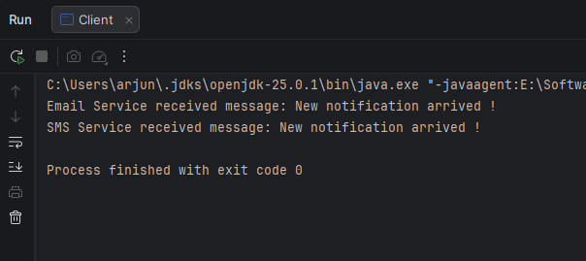

The Key advantages are
- Loose Coupling
- Easy to add/remove observers
- Automatic updates.

